Chapter 2 Acids Bases and Salts

**Indicators:** Indicators are substances which indicate the acidic or basic nature of the solution by the colour change.  
**Types of Indicator:** There are many types of indicators. Some common types of indicators are:

**1. Natural Indicators:** Indicators obtained from natural sources are called Natural Indicators. Litmus, turmeric, red cabbage, China rose, etc., are some common natural indicators used widely to show the acidic or basic character of substances.  
**Litmus:** Litmus is obtained from lichens. The solution of litmus is purple in colour. Litmus paper comes in two colours- blue and red.  
An acid turns blue litmus paper red.  
A base turns red litmus paper blue.

|  |  |  |  |
| --- | --- | --- | --- |
| **Indicator** | **Original Colour** | **Acid** | **Base** |
| Red litmus | Red | No Change | Blue |
| Blue litmus | Blue | Red | No change |
| Turmeric | Yellow | No Change | Reddish brown |
| Red cabbage juice | Purple | Reddish | Greenish yellow |
| Phenolphthalein | Colourless | Colourless | Pink |
| Methyl Orange | Orange | Red | Yellow |
| Onion | n/a | No change | Smell vanishes |
| Vanilla | n/a | No change | Smell vanishes |

**Turmeric:** Turmeric is another natural indicator. Turmeric is yellow in colour. Turmeric solution or paper turns reddish brown with base. Turmeric does not change colour with acid.

**Red Cabbage:** The juice of red cabbage is originally purple in colour. Juice of red cabbage turns reddish with acid and turns greenish with base.

**2. Olfactory Indicator:** Substances which change their smell when mixed with acid or base are known as Olfactory Indicators. For example; Onion, vanilla etc.  
**Onion:** Paste or juice of onion loses its smell when added with base. It does not change its smell with acid.  
**Vanilla:** The smell of vanilla vanishes with base, but its smell does not vanish with an acid.  
Olfactory Indicators are used to ensure the participation of visually impaired students in the laboratory.

**3. Synthetic Indicator:** Indicators that are synthesized in the laboratory are known as Synthetic Indicators. For example; Phenolphthalein, methyl orange, etc.  
Phenolphthalein is a colourless liquid. It remains colourless with acid but turns into pink with a base.  
Methyl orange is originally orange in colour. It turns into the red with acid and turns into yellow with base.

**Acids:** Acids are sour in taste, turn blue litmus red, and dissolve in water to release H+ ions.  
Example: Sulphuric acid (H2SO4), Acetic Acid (CH3COOH), Nitric Acid (HNO3) etc.  
Properties of Acids:

* Acids have a sour taste.
* Turns blue litmus red.
* Acid solution conducts electricity.
* Release H+ ions in aqueous solution.

**Types of Acids:** Acids are divided into two types on the basis of their occurrence i.e., Natural acids and Mineral acids.  
**(i) Natural Acids:** Acids which are obtained from natural sources are called Natural Acids or Organic Acids.  
Examples:  
Methanoic acid (HCOOH)  
Acetic acid (CH3COOH)  
Oxalic acid (C2H2O4) etc.

|  |  |
| --- | --- |
| **Organic Acids and their Sources** | |
| **Acids** | **Sources** |
| Acetic acid | Vinegar |
| Ascorbic acid | Guava, amla |
| Citric acid | Lemon, orange and other citrus fruits |
| Lactic acid | Sour milk, curd |
| Methanoic acid | Ant sting, nettle sting |
| Oxalic acid | Tomato |
| Tartaric acid | Tamarind |

**(ii) Mineral Acids:** Acids that are prepared from minerals are known as Mineral Acids Example; Inorganic acids, man-made acids or synthetic acid are also known as Mineral Acids.  
Example:  
Hydrochloric acid (HCl)  
Sulphuric acid (H2SO4)  
Nitric acid (HNO3)  
Carbonic acid (H2CO3)  
Phosphoric acid (H3PO4) etc.

**Chemical Properties of Acid:**  
**(i) Reaction of acids with metal:** Acids give hydrogen gas along with respective salt when they react with a metal.  
Metal + Acid → Salt + Hydrogen  
Examples:  
Hydrogen gas and zinc chloride are formed when hydrochloric acid reacts with zinc metal.  
Acids Bases and Salts Class 10 Notes Science Chapter 2 1

Hydrogen gas and sodium sulphate are formed when sulphuric acid reacts with sodium metal.  
Acids Bases and Salts Class 10 Notes Science Chapter 2 2

**Test For Hydrogen Gas:** The gas evolved after reaction of acid with metal can be tested by bringing a lighted candle near it. If the gas bums with a pop sound, then it confirms the evolution of hydrogen gas. Burning with pop sound is the characteristic test for hydrogen gas.

**(ii) Reaction of acids with metal carbonate:** Acids give carbon dioxide gas and respective salts along with water when they react with metal carbonates.  
Metal carbonate + Acid → Salt + Carbon dioxide + Water  
Examples:  
Hydrochloric acid gives carbon dioxide gas, sodium chloride along with water when reacts with sodium carbonate.  
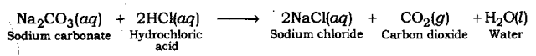

Sulphuric acid gives calcium sulphate, carbon dioxide gas, calcium sulphate and water when it reacts with calcium carbonate  
Acids Bases and Salts Class 10 Notes Science Chapter 2 4  
Nitric acid gives sodium nitrate, water and carbon dioxide gas when it reacts with sodium carbonate.  
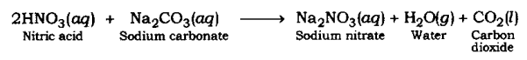

**(iii) Reaction of acid with hydrogen carbonates (bicarbonates):** Acids give carbon dioxide gas, respective salt and water when they react with metal hydrogen carbonate.  
Acid + Metal hydrogen carbonate → Salt + Carbon dioxide + Water  
Example:  
Sulphuric acid gives sodium sulphate, Carbon dioxide gas and water when it reacts with sodium bicarbonate.  
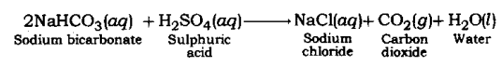

**Test For Evolution of Carbon Dioxide Gas:** Carbon dioxide turns lime water milky when passed through it. This is the characteristic test for carbon dioxide gas.  
The gas evolved because of reaction of the acid with metal carbonate or metal hydrogen carbonate turns lime water milky. This shows that the gas is carbon dioxide gas. This happens because of the formation of a white precipitate of calcium carbonate.  
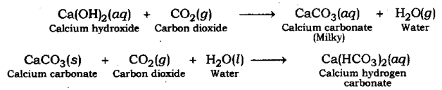  
But when excess of carbon dioxide is passed through lime water, it makes milky colour of lime water disappear. This happens because of formation of calcium hydrogen carbonate. As calcium hydrogen carbonate is soluble in water, thus, the milky colour of solution mixture disappears.

**Common in Acids:** Acids give hydrogen gas when they react with metal. This shows that all acids contains hydrogen. For example; Hydrochloric acid (HCl), sulphuric acid (H2SO4), nitric acid (HNO3), etc.  
When an acid is dissolved in water, it dissociates hydrogen. The dissociation of hydrogen ion in aqueous solution is the common property in all acids. Because of the dissociation of hydrogen ion in aqueous solution, an acid shows acidic behaviour.  
Examples:  
Hydrochloric acid (HCl) gives hydrogen ion (H+) and chloride ion (Cl–) when it is dissolved in water.  
Acids Bases and Salts Class 10 Notes Science Chapter 2 8  
Acetic acid (CH3COOH) gives acetate ion (CH3COO–) and hydrogen ion (H+).  
Acids Bases and Salts Class 10 Notes Science Chapter 2 9

**Acids**

**Strong Acids**  
An acid which is completely ionised in water and produces (H+) is called Strong Acid.  
Examples: Hydrochloric acid (HCl), Sulphuric acid (H2SO4), Nitric acid (HNO3)

**Weak Acids**  
An acid which is partially ionised in water and thus produces a small amount of hydrogen ions (H+) is called a Weak Acid.  
Example: Acetic acid (CH3COOH), Carbonic acid (H2CO3)

When a concentrated solution of acid is diluted by mixing water, then the concentration of Hydrogen ions (H+) or hydronium ion (H3O–) per unit volume decreases.

**Bases:** Bases are bitter in taste, have soapy touch, turn red litmus blue and give hydroxide ions (OH–) in aqueous solution.  
Examples: Sodium hydroxide (caustic soda) – NaOH  
Calcium hydroxide – Ca(OH)2  
Potassium hydroxide (caustic potash) – (KOH)

Properties of Bases:

* Have a bitter taste.
* Soapy to touch.
* Turns red litmus blue.
* Conducts electricity in solution.
* Release OH– ions in Aqueous Solution

**Types of bases:** Bases can be divided in two types – Water soluble and Water-insoluble.  
The hydroxide of alkali and alkaline earth metals are soluble in water. These are also known as alkali.  
For example; sodium hydroxide, magnesium hydroxide, calcium hydroxide, etc. Alkali is considered a strong base.

**Chemical properties of bases:**  
**(i) Reaction of Base with Metals:** When alkali (base) reacts with metal, it produces salt and hydrogen gas.  
Alkali + Metal → Salt + Hydrogen  
Examples: Sodium hydroxide gives hydrogen gas and sodium zincate when reacts with zinc metal.  
Acids Bases and Salts Class 10 Notes Science Chapter 2 10  
Sodium aluminate and hydrogen gas are formed when sodium hydroxide reacts with aluminium metal.  
Acids Bases and Salts Class 10 Notes Science Chapter 2 11

**(ii) Reaction of Base with Oxides of Non-metals:** Non-metal oxides are acidic in nature. For example; carbon dioxide is a non-metal oxide. When carbon dioxide is dissolved in water it produces carbonic acid.  
Therefore, when a base reacts with non-metal oxide, both neutralize each other resulting respective salt and water.  
Base + Non-metal oxide → Salt + Water  
(Non-metal oxides are acidic in nature)  
Examples:  
Sodium hydroxide gives sodium carbonate and water when it reacts with carbon dioxide.  
Acids Bases and Salts Class 10 Notes Science Chapter 2 12  
Calcium hydroxide gives calcium carbonate and water when it reacts with carbon dioxide.  
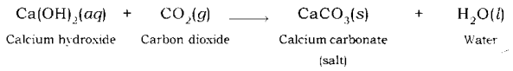

**(iii) Neutralisation Reaction:** An acid neutralizes a base when they react with each other and respective salt and water are formed.  
Acid + Base → Salt + Water  
Since, the reaction between acid and base both neutralize each other, hence, it is also known as Neutralization Reaction.  
Examples: Sodium chloride and water are formed when hydrochloric acid reacts with sodium hydroxide (a strong base).  
Acids Bases and Salts Class 10 Notes Science Chapter 2 14  
In a similar way, calcium chloride is formed along with water when hydrochloric acid reacts with calcium hydroxide (a base).  
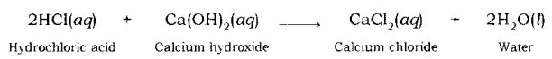

**(iv) Reaction of Acid with Metal Oxides:** Metal oxides are basic in nature. Thus, when an acid reacts with a metal oxide both neutralize each other. In this reaction, the respective salt and water are formed.  
Acid + Metal Oxide → Salt + Water  
(Metal oxides are basic in nature)  
Examples:  
Calcium is a metal, thus, calcium oxide is a metallic oxide which is basic in nature. When an acid, such as hydrochloric acid, reacts with calcium oxide, neutralization reaction takes place and calcium chloride, along with water is formed.  
Acids Bases and Salts Class 10 Notes Science Chapter 2 16  
Similarly, when sulphuric acid reacts with zinc oxide, zinc sulphate and water are formed.  
Acids Bases and Salts Class 10 Notes Science Chapter 2 17

**Common in all bases:** A base dissociates hydroxide ion in water, which is responsible for the basic behaviour of a compound.  
Example: When sodium hydroxide is dissolved in water, it dissociates hydroxide ion and sodium ion.  
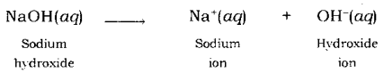  
Similarly, when potassium hydroxide is dissolved in water, it dissociates hydroxide ion and potassium ion.  
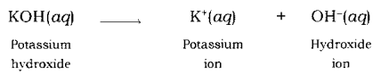  
Thus, the base shows its basic character because of dissociation of hydroxide ion.

**Neutralisation Reaction:** When an acid reacts with a base, the hydrogen ion of acid combines with the hydroxide ion of base and forms water. As these ions combine together and form water instead of remaining free, thus, both neutralize each other.  
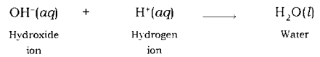  
Example: When sodium hydroxide (a base) reacts with hydrochloric acid, sodium hydroxide breaks into a sodium ion and hydroxide ion and hydrochloric acid breaks into hydrogen ion and chloride ion.  
Hydrogen ion and hydroxide ion combine together and form water, while sodium ion and chloride ion combine together and form sodium chloride.  
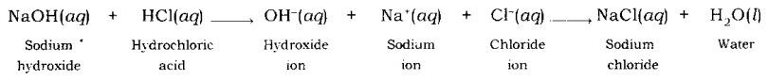

**Dilution of Acid and Base:** The concentration of hydrogen ion in an acid and hydroxide ion in a base, per unit volume, shows the concentration of acid or base.

By mixing of acid to water, the concentration of hydrogen ion per unit volume decreases. Similarly, by addition of base to water, the concentration of hydroxide ion per unit volume decreases. This process of addition of acid or base to water is called Dilution and the acid or base is called Diluted.

The dilution of acid or base is exothermic. Thus, acid or base is always added to water and water is never added to acid or base. If water is added to a concentrated acid or base, a lot of heat is generated, which may cause splashing out of acid or base and may cause severe damage as concentrated acid and base are highly corrosive.

**Strength of Acid and Base:** Acids in which complete dissociation of hydrogen ion takes place are called Strong Acids. Similarly, bases in which complete dissociation of hydroxide ion takes place are called Strong Bases.  
In mineral acid, such as hydrochloric acid, sulphuric acid, nitric acid, etc. hydrogen ion dissociates completely and hence, they are considered as strong acids. Since inorganic acids hydrogen ions do not dissociate completely, so they are weak acids.  
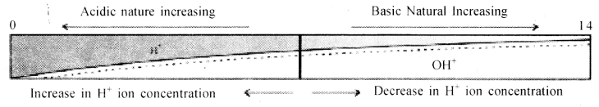  
For water or neutral solutions : pH = 7  
For acidic solutions : pH < 7  
For basic solution : pH > 7

**Universal Indicator:** Using a litmus paper, phenolphthalein, methyl orange, etc. only the acidic or basic character of a solution can be determined, but the use of these indicators does not give the idea about the strength of acid or base. So, to get the strength as well as acidic and basic nature of a given solution universal indicator is used.

Universal indicator shows different colour over the range of pH value from 1 to 14 for a given solution. Universal indicator is available both in the form of strips and solution. Universal indicator is the combination of many indicators, such as water, propanol, phenolphthalein, sodium salt, sodium hydroxide, methyl red, bromothymol blue monosodium salt, and thymol blue monosodium salt. The colour matching chart is supplied with a universal indicator which shows the different colours for different values of pH.  
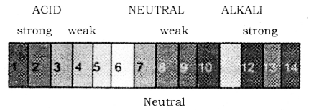

pH value shown by different colours role of pH everyday life:  
**(i) pH in our digestive system:** Dilute HCl (Hydrochloric acid) helps in digestion of food (proteins) in our stomach. Excess acid in stomach causes acidity (indigestion). Antacids like magnesium hydroxide [Mg(OH)2] also known as milk of magnesia and sodium hydrogen carbonate (baking soda) are used to neutralize excess acid.

**(ii) Tooth decay caused by acids:** The bacteria present in our mouth converts the sugar into acids. When the pH of acid formed in the mouth falls below 5.5, tooth-decaying starts. The excess acid has to be removed by cleaning the teeth with a good quality toothpaste because these kinds of toothpaste are alkaline in nature.

**(iii) Soil of pH and plant growth:** Most of the plants have a healthy growth when the soil has a specific pH (close to 7) range which should be neither alkaline nor highly acidic. Therefore,

* Compound ‘X’ is Sodium hydroxide (NaOH).
* Compound ‘A’ is Zinc sulphate (ZnSO4).
* Compound ‘B’ is Sodium chloride (NaCl).
* Compound ‘C’ is Sodium acetate (CH3COONa)

**Salts:** Salts are the ionic compounds which are produced after the neutralization reaction between acid and base. Salts are electrically neutral. There are number of salts but sodium chloride is the most common among them. Sodium chloride is also known as table salt or common salt. Sodium chloride is used to enhance the taste of food.

Characteristics of salt:

* Most of the salts are crystalline soild.
* Salts may be transparent or opaque.
* Most of the salts are soluble in water.
* Solution of the salts conducts electricity in their molten state also.
* The salt may be salty, sour, sweet, bitter and umami (savoury).
* Neutral salts are odourless.
* Salts can be colourless or coloured.

**Family of Salt:** Salts having common acidic or basic radicals are said to belong to the same family.  
Example:  
(i) Sodium chloride (NaCl) and Calcium chloride (CaCl2) belongs to chloride family.  
(ii) Calcium chloride (CaCl2) and Calcium sulphate (CaSO4) belongs to calcium family.  
(iii) Zinc chloride (ZnCl2) and Zinc sulphate (ZnSO4) belongs to the zinc family.

**Neutral, Acidic and Basic Salts:**  
**(i) Neutral Salt:** Salts produced because of reaction between a strong acid and strong base are neutral in nature. The pH value of such salts is equal to 7, i.e. neutral.  
Example : Sodium chloride, Sodium sulphate. Postassium chloride, etc.

**Sodium chloride (NaCl):** It is formed after the reaction between hydrochloric acid (a strong acid) and sodium hydroxide (a strong base).  
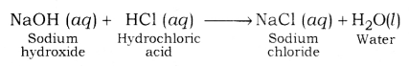

**Sodium Sulphate (Na2SO4):** It is formed after the reaction between sodium hydroxide (a strong base) and sulphuric acid ( a strong acid).  
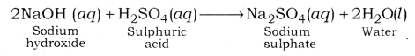

**Potassium Chloride (KCl):** It is formed after the reaction between potassium hydroxide (a strong base) and hydrochloric acid (a strong acid).  
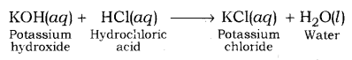

**(ii) Acidic Salts:** Salts which are formed after the reaction between a strong acid and weak base are called Acidic salts. The pH value of acidic salt is lower than 7. For example Ammonium sulphate, Ammonium chloride, etc.  
Ammonium chloride is formed after reaction between hydrochloric acid (a strong acid) and ammonium hydroxide (a weak base).  
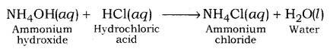  
Ammonium sulphate is formed after reaction between ammonium hydroxide (a weak base) and sulphuric acid (a strong acid).  
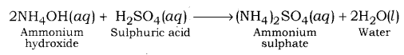

**(iii) Basic Salts:** Salts which are formed after the reaction between a weak acid and strong base are called Basic Salts. For example; Sodium carbonate, Sodium acetate, etc.  
Sodium carbonate is formed after the reaction between sodium hydroxide (a strong base) and carbonic acid (a weak acid).  
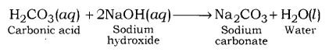  
Sodium acetate is formed after the reaction between a strong base, sodium hydroxide (a strong base) and acetic acid, (a weak acid).  
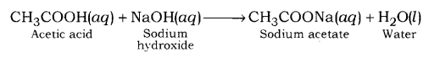

Cause of formation of acidic, basic and neutral salts:

* When a strong acid reacts with a weak base, the base is unable to fully neutralize the acid. Due to this, an acidic salt is formed.
* When a strong base reacts with a weak acid, the acid is unable to fully neutralize the base. Due to this, a basic salt is formed.
* When equally strong acid and a base react, they fully neutralize each other. Due to this, a neutral salt is formed.

pH value of salt:

* Neutral salt: The pH value of a neutral salt is almost equal to 7.
* Acidic salt: The pH value of an acidic salt is less than 7.
* Basic salt: The pH value of a basic salt is more than 7.

Some Important Chemical Compounds  
**1. Common Salt (Sodium Chloride):** Sodium chloride (NaCl) is also known as Common or Table Salt. It is formed after the reaction between sodium hydroxide and hydrochloric acid. It is a neutral salt. The pH value of sodium chloride is about 7. Sodium chloride is used to enhance the taste of food. Sodium chloride is used in the manufacturing of many chemicals.

**Important chemical from sodium chloride**  
**Sodium Hydroxide (NaOH):** Sodium hydroxide is a strong base. It is also known as caustic soda. It is obtained by the electrolytic decomposition of solution of sodium chloride (brine). In the process of electrolytic decomposition of brine (aqueous solution of sodium chloride), brine decomposes to form sodium hydroxide. In this process, chlorine is obtained at anode and hydrogen gas is obtained at cathode as by products. This whole process is known as Chlor – Alkali process.  
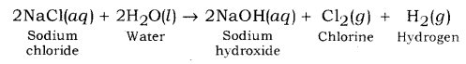

Use of products after the electrolysis of brine:

* Hydrogen gas is used as fuel, margarine, in making of ammonia for fertilizer, etc.
* Chlorine gas is used in water treatment, manufacturing of PVC, disinfectants, CFC, pesticides. It is also used in the manufacturing of bleaching powder and hydrochloric acid.
* Sodium hydroxide is used for degreasing of metals, manufacturing of paper, soap, detergents, artificial fibres, bleach, etc.

**2. Bleaching Powder (CaOCl2):** Bleaching powder is also known as chloride of lime. It is a solid and yellowish white in colour. Bleaching powder can be easily identified by the strong smell of chlorine.  
When calcium hydroxide (slaked lime) reacts with chlorine, it gives calcium oxychloride (bleaching powder) and water is formed.  
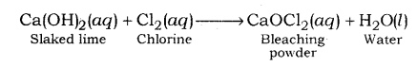  
Aqueous solution of bleaching powder is basic in nature. The term bleach means removal of colour. Bleaching powder is often used as bleaching agent. It works because of oxidation. Chlorine in the bleaching powder is responsible for bleaching effect.

Use of Bleaching Powder:

* Bleaching powder is used as disinfectant to clean water, moss remover, weed killers, etc.
* Bleaching powder is used for bleaching of cotton in textile industry, bleaching of wood pulp in paper industry.
* Bleaching powder is used as oxidizing agent in many industries, such as textiles industry, paper industry, etc.

**3. Baking Soda (NaHCO3):** Baking soda is another important product which can be obtained using byproducts of chlor – alkali process. The chemical name of baking soda is sodium hydrogen carbonate (NaHCO3) or sodium bicarbonate. Bread soda, cooking soda, bicarbonate of soda, sodium bicarb, bicarb of soda or simply bicarb, etc. are some other names of baking soda.

Preparation Method: Baking soda is obtained by the reaction of brine with carbon dioxide and ammonia. This is known as Solvay process.  
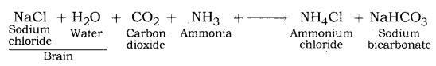  
In this process, calcium carbonate is used as the source of CO2 and the resultant calcium oxide is used to recover ammonia from ammonium chloride.

Properties of Sodium Bicarbonate:

* Sodium bicarbonate is white crystalline solid, but it appears as fine powder.
* Sodium hydrogen carbonate is amphoteric in nature.
* Sodium hydrogen carbonate is sparingly soluble in water.
* Thermal decomposition of sodium hydrogen carbonate (baking soda).
* When baking soda is heated, it decomposes into sodium carbonate, carbon dioxide and water.  
  2NaHCO3 + heat → Na2CO3 + CO2 + H2O
* Sodium carbonate formed after thermal decomposition of sodium hydrogen carbonate decomposes into sodium oxide and carbon dioxide on further heating.  
  Na2CO3 → Na2O + CO2  
  This reaction is known as Dehydration reaction.

Use of Baking Soda:

* Baking soda is used in making of baking powder, which is used in cooking as it produces carbon dioxide which makes the batter soft and spongy.
* Baking soda is used as an antacid.
* Baking soda is used in toothpaste which makes the teeth white and plaque free.
* Baking soda is used in cleansing of ornaments made of silver.
* Since sodium hydrogen carbonate gives carbon dioxide and sodium oxide on strong heating, thus, it, is used as a fire extinguisher.

**Baking Powder:** Baking powder produces carbon dioxide on heating, so it is used in cooking to make the batter spongy. Although, baking soda also produces carbon dioxide on heating, but it is not used in cooking because on heating, baking soda produces sodium carbonate along with carbon dioxide. The sodium carbonate, thus, produced, makes the taste bitter.  
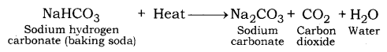  
Baking powder is the mixture of baking soda and a mild edible acid. Generally, tartaric acid is mixed with baking soda to make baking powder.  
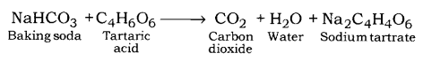  
When baking powder is heated, sodium hydrogen carbonate (NaHCO3) decomposes to give CO2 and sodium carbonate (Na2CO3). CO2 causes bread and cake fluffy. Tartaric acid helps to remove bitter taste due to formation of Na2CO3.

**4. Washing Soda (Sodium Carbonate)**  
**Preparation Method:** Sodium carbonate is manufactured by the thermal decomposition of sodium hydrogen carbonate obtained by Solvay process.  
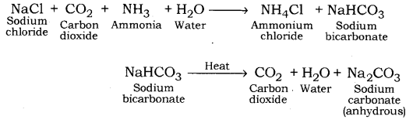  
The sodium carbonate obtained in this process is dry. It is called Soda ash or Anhydrous sodium carbonate. Washing soda is obtained by rehydration of anhydrous sodium carbonate.  
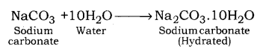  
Since there are 10 water molecules in washing soda, hence, it is known as Sodium Bicarbonate Decahydrate.  
Sodium carbonate is a crystalline solid and it is soluble in water when most of the carbonates are insoluble in water.

Use of sodium carbonate:

* It is used in the cleaning of cloths, especially in rural areas.
* In the making of detergent cake and powder.
* In removing the permanent hardness of water.
* It is used in glass and paper industries.

**The water of Crystallization:** Many salts contain water molecule and are known as Hydrated Salts. The water molecule present in salt is known as Water of crystallization.  
Examples:  
Copper sulphate pentahydrate (CuSO4.5H2O): Blue colour of copper sulphate is due to presence of 5 molecules of water. When copper sulphate is heated, it loses water molecules and turns: into grey – white colour, which is known as anhydrous copper sulphate. After adding water, anhydrous copper sulphate becomes blue again.  
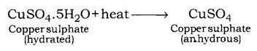  
**Acids:** Substances which turn blue litmus solution red are called acids. Acids are sour in taste.

**Bases:** Substances which change red litmus solution blue are called bases. They are bitter in taste.

**Mineral Acids:** Acids which are obtained from minerals like sulphates, nitrates, chlorides etc. are called mineral acids, example, H2SO4 (Sulphuric acid), HNO3 (Nitric acid) and HCl (Hydrochloric acid).

**Organic Acids:** Acids which are obtained from plants and animals are called organic acids. Example citric acid, ascorbic acid, tartaric acid, lactic acid, acetic acid.

**Hydronium Ions:** They are formed by the reaction of H+ (from acid) and H2O. It is because H+ is unstable.

**Universal Indicator:** A universal indicator is a mixture of indicators which shows a gradual but well-marked series of colour changes over a very wide range of change in concentration of H+ ions.

**Strong Acids:** Acids which dissociate into ions completely are called strong acids. Example, H2SO4, HCl.

**Weak Acids:** Acids which do not dissociate into ions completely are called weak acids. Example, citric acid, acetic acid.

**Chemical Properties of Acids:**

* Acids react with active metals to give salt and hydrogen gas.
* Acids react with metal carbonates and metal hydrogen carbonates to give salt, water and carbon dioxide.
* Acids react with bases to give salt and water. This reaction is called a neutralization reaction.
* Acids react with metal oxides to give salt and water.

**Chemical Properties of Bases:**

* **Reaction with metals:** Certain metals such as zinc, aluminium and tin react with alkali solutions on heating and hydrogen gas is evolved.
* **Reaction with acids:** Bases react with acids to form salt and water.

**Indicators:** Indicators are substances which indicate the acidic or basic nature of the solution by their colour change.

**pH Scale**: A scale for measuring hydrogen ion concentration in a solution.  
The pH of a solution is defined as the negative logarithm of hydrogen ion concentration in moles per litre.  
pH = -log [H+]  
pH = -log [H3O+]  
where [H+] or [H3O+] represents concentrations of hydrogen ions in a solution.

* The pH of a neutral solution is 7.
* The pH of an acidic solution is < 7.
* The pH of a basic solution is > 7.

Some Important Compounds and their Uses: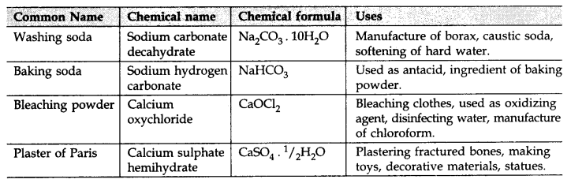

Equations of Acids, Bases and Salts:

* Acid + Metal → Salt + Hydrogen gas  
  H2SO4 + Zn → ZnSO4 + H2
* Base + Metal → Salt + Hydrogen gas  
  2NaOH + Zn → Na2ZnO2 (Sodium zincate) + H2
* Base + Acid → Salt + Water  
  NaOH (aq) + HCl (aq) → NaCl (aq) + H2O (l)
* Acids give hydronium ions in water  
  HCl + H2O → H3O+ + Cl–
* Bases generate OH- ions in water  
  NaOH (aq) + H2O → Na+ (aq) + O– (aq)

**Reactions Of Important Chemical Compounds:**

* **Preparation of Bleaching powder:** By the action of chlorine on dry slaked lime  
  Ca(OH)2 + Cl2 → CaOCl2 + H2O
* On heating, baking soda liberates CO2
* 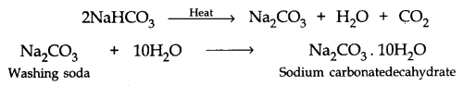
* **Preparation of Plaster of Paris:**  
  